

# STUDENT NAME : SANJAY KUMAR T

**STAFF NAME : Ms JOHNCY**

# COURSE NAME : WEB DEVELOPMENT

**DATE : 11-01-2024**

ACKNOWLEDGEMENT

First of all, I thank **God** almighty for giving us the wisdom, grace and knowledge to complete this project successfully and also for showering his choicest blessing upon us.

I express my gratitude to **Ms JOHNCY** who co-ordinate and guided us in this project through this **WEB DEVELOPMENT** course. I take this pleasant opportunity to convey my thanks to her for her kind co-operation, requirements and access to complete my project work.

I also express my gratitude to **Ms JOHNCY Technical Leader** who co-ordinate and guided us in this project and all through this **WEB DEVELOPMENT** course. I take this pleasant opportunity to convey my thanks to him for his kind co-operation, requirements and access to complete my project work.

I am thankful to **all the Staff** of Networkz Systems and my **friend who has given their timely support and helped** to bring out our project a successful one.

Above all, I remain greatly thankful to my beloved **Parents** who inspired and guided us on the right path and for being the backbone of all the successful endeavours in our life.

# SANJAY KUMAR T

**(WEB DEVELOPMENT)**

INDEX

|  |  |  |
| --- | --- | --- |
| **Serial No** | **Contents** | **Page No** |
| **1** | **Introduction** | **4** |
| **2** | **Project Name** | **7** |
| **3** | **Software Requirements** | **7** |
| **4** | **Codes** | **8** |
| **5** | **Screen Shots** | **130** |
| **6** | **Conclusion** | **132** |

**INTRODUCTION**

**COURSE INTRODUCTION**

Web development refers to the building, creating, and maintaining of websites.It includes aspects such as web design, web publishing, web programming, and database management. It is the creation of an application that works over the Internet.

The word Web Development is made up of two words, that is:

* **Web:** It refers to websites, web pages or anything that works over the internet.
* **Development:** Building the application from scratch.

**Frontend Development:** The part of a website that the user interacts directly with is called the front end. It is also called the ‘client side’ of the application.

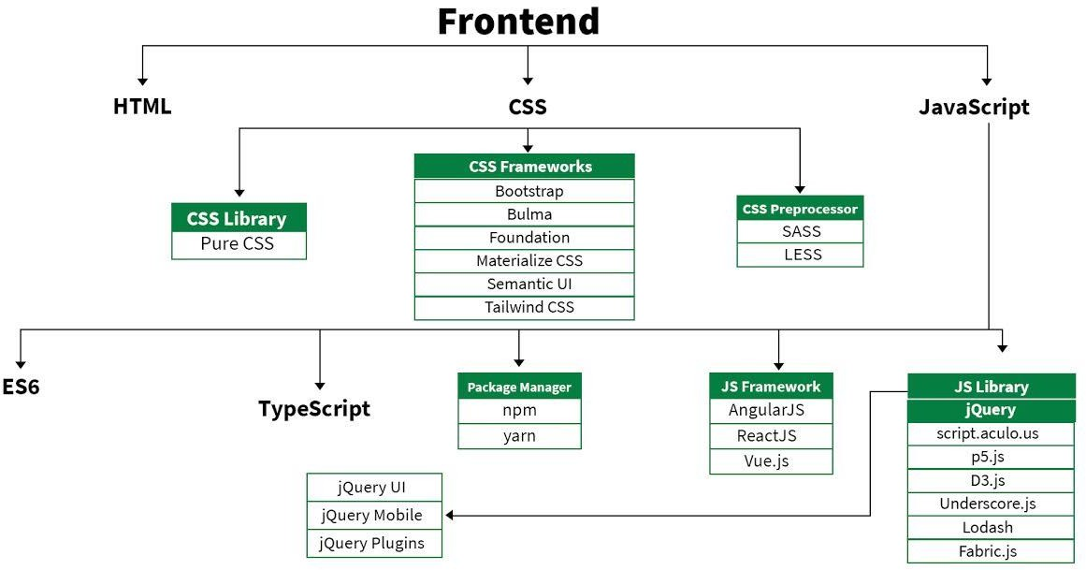**Frontend Roadmap:**

* [**HTML**](https://www.geeksforgeeks.org/html-tutorials/): HTML stands for HyperText Markup Language. It is used to design the front-end portion of web pages using markup language. It acts as a skeleton for a website since it is used to make the structure of a website.
* [**CSS**](https://www.geeksforgeeks.org/css-tutorials/)**:** Cascading Style Sheets fondly referred to as CSS is a simply designed language intended to simplify the process of making web pages presentable. It is used to style our website.
* [**JavaScript**](https://www.geeksforgeeks.org/javascript-tutorial/)**:** JavaScript is a scripting language used to provide dynamic behaviour to our website.
* [**Bootstrap:**](https://www.geeksforgeeks.org/bootstrap-tutorials/) Bootstrap is a free and open-source tool collection for

creating responsive websites and web applications. It is the most popular CSS framework for developing responsive, mobile-first websites. Nowadays, the websites are perfect for all browsers (IE, Firefox, and Chrome) and all sizes of screens (Desktop, Tablets, Phablets, and Phones).

* + [Bootstrap 4](https://www.geeksforgeeks.org/bootstrap-4-introduction/)
  + [Bootstrap 5](https://www.geeksforgeeks.org/bootstrap-5-introduction/)

## Frontend Frameworks and Libraries:

* [jQuery](https://www.geeksforgeeks.org/jquery-tutorials/)
* [Bootstrap](https://www.geeksforgeeks.org/bootstrap-tutorials/)
* [Material UI](https://www.geeksforgeeks.org/material-ui-introduction-and-installation-for-react/)
* [Tailwind CSS](https://www.geeksforgeeks.org/css-tailwind-introduction/)
* [jQuery UI](https://www.geeksforgeeks.org/tag/jquery-ui/)
* Some other libraries and frameworks

are: [Handlebar.js](https://www.geeksforgeeks.org/handlebars-templating-in-expressjs/) [Backbone.js](https://www.geeksforgeeks.org/difference-between-backbone-js-and-angular-js/), [Ember.js](https://www.geeksforgeeks.org/emberjs-vs-reactjs/) etc.

**PROJECT NAME**

**Marvel website**

**INTRODUCTION**

Welcome to our Marvel Universe Hub! Discover a streamlined navigation bar for Home, Series, Cartoons, Movies, and About, plus an easy Sign In option. Dive into key highlights with the dynamic slider and explore the latest Marvel movies, series, and cartoons in a dedicated section. Movie enthusiasts can check subscription plans in the pricing table. Our platform, committed to user-friendly design, responsive functionality, and engaging content, invites you to immerse in the rich Marvel Cinematic Universe experience. Join us on this epic journey where fandom and innovation converge seamlessly.

## SOFTWARE REQUIREMENTS

## Software Requirements

Front End:

* HTML
* CSS
* JAVASCRIPT
* BOOTSTRAP

**CODES**

**HTML CODES**

**Index.html**

<!DOCTYPE html>

<html lang="en">

<head>

<meta charset="UTF-8">

<meta http-equiv="X-UA-Compatible" content="IE=edge">

<meta name="viewport" content="width=device-width, initial-scale=1.0">

<title>

Marvel Movie Website

</title>

<!-- GOOGLE FONTS -->

<link rel="preconnect" href="https://fonts.gstatic.com">

<link href="https://fonts.googleapis.com/css2?family=Cairo:wght@200;300;400;600;700;900&display=swap" rel="stylesheet">

<!-- OWL CAROUSEL -->

<link rel="stylesheet" href="https://cdnjs.cloudflare.com/ajax/libs/OwlCarousel2/2.3.4/assets/owl.carousel.min.css" integrity="sha512-tS3S5qG0BlhnQROyJXvNjeEM4UpMXHrQfTGmbQ1gKmelCxlSEBUaxhRBj/EFTzpbP4RVSrpEikbmdJobCvhE3g==" crossorigin="anonymous" />

<!-- BOX ICONS -->

<link href='https://unpkg.com/boxicons@2.0.7/css/boxicons.min.css' rel='stylesheet'>

<!-- APP CSS -->

<link rel="stylesheet" href="grid.css">

<link rel="stylesheet" href="app.css">

</head>

<body>

<!-- NAV -->

<div class="nav-wrapper">

<div class="container">

<div class="nav">

<a href="#" class="logo">

<i class='bx bx-movie-play main-color'></i>KlM<span class="main-color">i</span>x

</a>

<ul class="nav-menu" id="nav-menu">

<li><a href="#hom">Home</a></li>

<li><a href="#cart">Cartoon</a></li>

<li><a href="#mov">Movies</a></li>

<li><a href="#seri">Series</a></li>

<li><a href="#abo">About</a></li>

<li>

<a href="login.html" class="btn btn-hover">

<span>Sign in</span>

</a>

</li>

</ul>

<!-- MOBILE MENU TOGGLE -->

<div class="hamburger-menu" id="hamburger-menu">

<div class="hamburger"></div>

</div>

</div>

</div>

</div>

<!-- END NAV -->

<!-- HERO SECTION -->

<div class="hero-section" id="hom">

<!-- HERO SLIDE -->

<div class="hero-slide">

<div class="owl-carousel carousel-nav-center" id="hero-carousel">

<!-- SLIDE ITEM -->

<div class="hero-slide-item">

<img src="./images/black-banner.png" alt="">

<div class="overlay"></div>

<div class="hero-slide-item-content">

<div class="item-content-wraper">

<div class="item-content-title top-down">

Black Panther

</div>

<div class="movie-infos top-down delay-2">

<div class="movie-info">

<i class="bx bxs-star"></i>

<span>9.5</span>

</div>

<div class="movie-info">

<i class="bx bxs-time"></i>

<span>120 mins</span>

</div>

<div class="movie-info">

<span>HD</span>

</div>

<div class="movie-info">

<span>16+</span>

</div>

</div>

<div class="item-content-description top-down delay-4">

Black Panther, T'Challa is crowned king of Wakanda following his father's death, but he is challenged by Killmonger (Jordan), who plans to abandon the country's isolationist policies and begin a global revolution.

</div>

<div class="item-action top-down delay-6">

<a href="https://isaidub6.com/movie/black-panther-2018-tamil-dubbed-movie/" class="btn btn-hover">

<i class="bx bxs-right-arrow"></i>

<span>Watch now</span>

</a>

</div>

</div>

</div>

</div>

<!-- END SLIDE ITEM -->

<!-- SLIDE ITEM -->

<div class="hero-slide-item">

<img src="images/captain-america-holding-thor-hammer-mjolnir-shield-wallpaper-2560x1600_7.jpg" alt="">

<div class="overlay"></div>

<div class="hero-slide-item-content">

<div class="item-content-wraper">

<div class="item-content-title top-down">

Captain America

</div>

<div class="movie-infos top-down delay-2">

<div class="movie-info">

<i class="bx bxs-star"></i>

<span>9.5</span>

</div>

<div class="movie-info">

<i class="bx bxs-time"></i>

<span>120 mins</span>

</div>

<div class="movie-info">

<span>HD</span>

</div>

<div class="movie-info">

<span>16+</span>

</div>

</div>

<div class="item-content-description top-down delay-4">

Captain America's civilian identity is Steve Rogers, a frail man enhanced to the peak of human physical perfection by an experimental "super-soldier serum" after joining the United States Army to aid the country's efforts in World War II.

</div>

<div class="item-action top-down delay-6">

<a href="https://isaidub6.com/movie/captain-america-duology-tamil-dubbed-collections/" class="btn btn-hover">

<i class="bx bxs-right-arrow"></i>

<span>Watch now</span>

</a>

</div>

</div>

</div>

</div>

<!-- END SLIDE ITEM -->

<!-- SLIDE ITEM -->

<div class="hero-slide-item">

<img src="./images/wanda-banner.jpg" alt="">

<div class="overlay"></div>

<div class="hero-slide-item-content">

<div class="item-content-wraper">

<div class="item-content-title top-down">

Wanda Vision

</div>

<div class="movie-infos top-down delay-2">

<div class="movie-info">

<i class="bx bxs-star"></i>

<span>9.5</span>

</div>

<div class="movie-info">

<i class="bx bxs-time"></i>

<span>120 mins</span>

</div>

<div class="movie-info">

<span>HD</span>

</div>

<div class="movie-info">

<span>16+</span>

</div>

</div>

<div class="item-content-description top-down delay-4">

Wanda is initially depicted as a Sokovian refugee who, along with her twin brother Pietro, volunteers to be experimented on by Hydra. The Mind Stone amplifies her natural telekinetic and energy manipulation abilities known as Chaos magic.

</div>

<div class="item-action top-down delay-6">

<a href="https://isaidub6.com/movie/72345/" class="btn btn-hover">

<i class="bx bxs-right-arrow"></i>

<span>Watch now</span>

</a>

</div>

</div>

</div>

</div>

<!-- END SLIDE ITEM -->

</div>

</div>

<!-- END HERO SLIDE -->

<!-- TOP MOVIES SLIDE -->

<div class="top-movies-slide">

<div class="owl-carousel" id="top-movies-slide">

<!-- MOVIE ITEM -->

<div class="movie-item">

<img src="images/web series/jessicajoness3_lob_crd_04.jpg" alt="">

<div class="movie-item-content">

<div class="movie-item-title">

Jessica Jones

</div>

<div class="movie-infos">

<div class="movie-info">

<i class="bx bxs-star"></i>

<span>9.5</span>

</div>

<div class="movie-info">

<i class="bx bxs-time"></i>

<span>120 mins</span>

</div>

<div class="movie-info">

<span>HD</span>

</div>

<div class="movie-info">

<span>16+</span>

</div>

</div>

</div>

</div>

<!-- END MOVIE ITEM -->

<!-- MOVIE ITEM -->

<div class="movie-item">

<img src="images/cartoon img/whatif-1647462169.png" alt="">

<div class="movie-item-content">

<div class="movie-item-title">

What If

</div>

<div class="movie-infos">

<div class="movie-info">

<i class="bx bxs-star"></i>

<span>9.5</span>

</div>

<div class="movie-info">

<i class="bx bxs-time"></i>

<span>120 mins</span>

</div>

<div class="movie-info">

<span>HD</span>

</div>

<div class="movie-info">

<span>16+</span>

</div>

</div>

</div>

</div>

<!-- END MOVIE ITEM -->

<!-- MOVIE ITEM -->

<div class="movie-item">

<img src="images/cartoon img/3014613-fcbd.jpg" alt="">

<div class="movie-item-content">

<div class="movie-item-title">

Infinity

</div>

<div class="movie-infos">

<div class="movie-info">

<i class="bx bxs-star"></i>

<span>9.5</span>

</div>

<div class="movie-info">

<i class="bx bxs-time"></i>

<span>120 mins</span>

</div>

<div class="movie-info">

<span>HD</span>

</div>

<div class="movie-info">

<span>16+</span>

</div>

</div>

</div>

</div>

<!-- END MOVIE ITEM -->

<!-- MOVIE ITEM -->

<div class="movie-item">

<img src="images/web series/loki_lob_crd_04.jpg" alt="">

<div class="movie-item-content">

<div class="movie-item-title">

Loki

</div>

<div class="movie-infos">

<div class="movie-info">

<i class="bx bxs-star"></i>

<span>9.5</span>

</div>

<div class="movie-info">

<i class="bx bxs-time"></i>

<span>120 mins</span>

</div>

<div class="movie-info">

<span>HD</span>

</div>

<div class="movie-info">

<span>16+</span>

</div>

</div>

</div>

</div>

<!-- END MOVIE ITEM -->

<!-- MOVIE ITEM -->

<div class="movie-item">

<img src="images/movie img/theguardiansofthegalaxyholidayspecial_lob_crd_02.jpg" alt="">

<div class="movie-item-content">

<div class="movie-item-title">

The guardians of the galaxy holiday special

</div>

<div class="movie-infos">

<div class="movie-info">

<i class="bx bxs-star"></i>

<span>9.5</span>

</div>

<div class="movie-info">

<i class="bx bxs-time"></i>

<span>120 mins</span>

</div>

<div class="movie-info">

<span>HD</span>

</div>

<div class="movie-info">

<span>16+</span>

</div>

</div>

</div>

</div>

<!-- END MOVIE ITEM -->

<!-- MOVIE ITEM -->

<div class="movie-item">

<img src="images/movie img/antmanandthewaspquantumania_lob_crd_03.jpg" alt="">

<div class="movie-item-content">

<div class="movie-item-title">

Ant-Man

</div>

<div class="movie-infos">

<div class="movie-info">

<i class="bx bxs-star"></i>

<span>9.5</span>

</div>

<div class="movie-info">

<i class="bx bxs-time"></i>

<span>120 mins</span>

</div>

<div class="movie-info">

<span>HD</span>

</div>

<div class="movie-info">

<span>16+</span>

</div>

</div>

</div>

</div>

<!-- END MOVIE ITEM -->

</div>

</div>

<!-- END TOP MOVIES SLIDE -->

</div>

<!-- END HERO SECTION -->

<!-- LATEST MOVIES SECTION -->

<div class="section">

<div class="container">

<div class="section-header" id="mov">

latest movies

</div>

<div class="movies-slide carousel-nav-center owl-carousel">

<!-- MOVIE ITEM -->

<a href="#" class="movie-item">

<img src="images/movie img/antmanandthewaspquantumania_lob_crd_03.jpg" alt="">

<div class="movie-item-content">

<div class="movie-item-title">

Antman and the wasp Quantumania

</div>

<div class="movie-infos">

<div class="movie-info">

<i class="bx bxs-star"></i>

<span>9.5</span>

</div>

<div class="movie-info">

<i class="bx bxs-time"></i>

<span>120 mins</span>

</div>

<div class="movie-info">

<span>HD</span>

</div>

<div class="movie-info">

<span>16+</span>

</div>

</div>

</div>

</a>

<!-- END MOVIE ITEM -->

<!-- MOVIE ITEM -->

<a href="#" class="movie-item">

<img src="images/movie img/list-of-marvel-movies-in-order33.png" alt="">

<div class="movie-item-content">

<div class="movie-item-title">

Doctor Strange Multiverse of Madness

</div>

<div class="movie-infos">

<div class="movie-info">

<i class="bx bxs-star"></i>

<span>9.5</span>

</div>

<div class="movie-info">

<i class="bx bxs-time"></i>

<span>120 mins</span>

</div>

<div class="movie-info">

<span>HD</span>

</div>

<div class="movie-info">

<span>16+</span>

</div>

</div>

</div>

</a>

<!-- END MOVIE ITEM -->

<!-- MOVIE ITEM -->

<a href="#" class="movie-item">

<img src="images/movie img/spider-mannowayhome_lob_crd_03.jpg" alt="">

<div class="movie-item-content">

<div class="movie-item-title">

Spider-Man No Way Home

</div>

<div class="movie-infos">

<div class="movie-info">

<i class="bx bxs-star"></i>

<span>9.5</span>

</div>

<div class="movie-info">

<i class="bx bxs-time"></i>

<span>120 mins</span>

</div>

<div class="movie-info">

<span>HD</span>

</div>

<div class="movie-info">

<span>16+</span>

</div>

</div>

</div>

</a>

<!-- END MOVIE ITEM -->

<!-- MOVIE ITEM -->

<a href="#" class="movie-item">

<img src="images/movie img/theguardiansofthegalaxyholidayspecial_lob_crd_02.jpg" alt="">

<div class="movie-item-content">

<div class="movie-item-title">

The Guardians of the galaxy holiday special

</div>

<div class="movie-infos">

<div class="movie-info">

<i class="bx bxs-star"></i>

<span>9.5</span>

</div>

<div class="movie-info">

<i class="bx bxs-time"></i>

<span>120 mins</span>

</div>

<div class="movie-info">

<span>HD</span>

</div>

<div class="movie-info">

<span>16+</span>

</div>

</div>

</div>

</a>

<!-- END MOVIE ITEM -->

<!-- MOVIE ITEM -->

<a href="#" class="movie-item">

<img src="images/movie img/blackwidow_lob_crd_06.jpg" alt="">

<div class="movie-item-content">

<div class="movie-item-title">

Black Widow

</div>

<div class="movie-infos">

<div class="movie-info">

<i class="bx bxs-star"></i>

<span>9.5</span>

</div>

<div class="movie-info">

<i class="bx bxs-time"></i>

<span>120 mins</span>

</div>

<div class="movie-info">

<span>HD</span>

</div>

<div class="movie-info">

<span>16+</span>

</div>

</div>

</div>

</a>

<!-- END MOVIE ITEM -->

<!-- MOVIE ITEM -->

<a href="#" class="movie-item">

<img src="images/movie img/eternals_lob_crd_06.jpg" alt="">

<div class="movie-item-content">

<div class="movie-item-title">

Eternals

</div>

<div class="movie-infos">

<div class="movie-info">

<i class="bx bxs-star"></i>

<span>9.5</span>

</div>

<div class="movie-info">

<i class="bx bxs-time"></i>

<span>120 mins</span>

</div>

<div class="movie-info">

<span>HD</span>

</div>

<div class="movie-info">

<span>16+</span>

</div>

</div>

</div>

</a>

<!-- END MOVIE ITEM -->

<!-- MOVIE ITEM -->

<a href="#" class="movie-item">

<img src="images/movie img/guardiansofthegalaxy_lob_crd_03.jpg" alt="">

<div class="movie-item-content">

<div class="movie-item-title">

Guardians of the galaxy

</div>

<div class="movie-infos">

<div class="movie-info">

<i class="bx bxs-star"></i>

<span>9.5</span>

</div>

<div class="movie-info">

<i class="bx bxs-time"></i>

<span>120 mins</span>

</div>

<div class="movie-info">

<span>HD</span>

</div>

<div class="movie-info">

<span>16+</span>

</div>

</div>

</div>

</a>

<!-- END MOVIE ITEM -->

<!-- MOVIE ITEM -->

<a href="#" class="movie-item">

<img src="images/movie img/captainmarvel_lob_crd_06.jpg" alt="">

<div class="movie-item-content">

<div class="movie-item-title">

Captain Marvel

</div>

<div class="movie-infos">

<div class="movie-info">

<i class="bx bxs-star"></i>

<span>9.5</span>

</div>

<div class="movie-info">

<i class="bx bxs-time"></i>

<span>120 mins</span>

</div>

<div class="movie-info">

<span>HD</span>

</div>

<div class="movie-info">

<span>16+</span>

</div>

</div>

</div>

</a>

<!-- END MOVIE ITEM -->

<!-- MOVIE ITEM -->

<a href="#" class="movie-item">

<img src="images/movie img/end-game.jpg" alt="">

<div class="movie-item-content">

<div class="movie-item-title">

Avengers End Game

</div>

<div class="movie-infos">

<div class="movie-info">

<i class="bx bxs-star"></i>

<span>9.5</span>

</div>

<div class="movie-info">

<i class="bx bxs-time"></i>

<span>120 mins</span>

</div>

<div class="movie-info">

<span>HD</span>

</div>

<div class="movie-info">

<span>16+</span>

</div>

</div>

</div>

</a>

<!-- END MOVIE ITEM -->

<!-- MOVIE ITEM -->

<a href="#" class="movie-item">

<img src="images/movie img/avengersinfinitywar_lob_crd_02_1.jpg" alt="">

<div class="movie-item-content">

<div class="movie-item-title">

Avengers Infinity War

</div>

<div class="movie-infos">

<div class="movie-info">

<i class="bx bxs-star"></i>

<span>9.5</span>

</div>

<div class="movie-info">

<i class="bx bxs-time"></i>

<span>120 mins</span>

</div>

<div class="movie-info">

<span>HD</span>

</div>

<div class="movie-info">

<span>16+</span>

</div>

</div>

</div>

</a>

<!-- END MOVIE ITEM -->

<!-- MOVIE ITEM -->

<a href="#" class="movie-item">

<img src="images/movie img/blackpanther_lob_crd_01_4.jpg" alt="">

<div class="movie-item-content">

<div class="movie-item-title">

Black Panther

</div>

<div class="movie-infos">

<div class="movie-info">

<i class="bx bxs-star"></i>

<span>9.5</span>

</div>

<div class="movie-info">

<i class="bx bxs-time"></i>

<span>120 mins</span>

</div>

<div class="movie-info">

<span>HD</span>

</div>

<div class="movie-info">

<span>16+</span>

</div>

</div>

</div>

</a>

<!-- END MOVIE ITEM -->

<!-- MOVIE ITEM -->

<a href="#" class="movie-item">

<img src="images/movie img/fox_x-mendaysoffuturepast_lob_crd_01.jpg" alt="">

<div class="movie-item-content">

<div class="movie-item-title">

Fox_X-Men Days of Future Past

</div>

<div class="movie-infos">

<div class="movie-info">

<i class="bx bxs-star"></i>

<span>9.5</span>

</div>

<div class="movie-info">

<i class="bx bxs-time"></i>

<span>120 mins</span>

</div>

<div class="movie-info">

<span>HD</span>

</div>

<div class="movie-info">

<span>16+</span>

</div>

</div>

</div>

</a>

<!-- END MOVIE ITEM -->

<!-- MOVIE ITEM -->

<a href="#" class="movie-item">

<img src="images/movie img/thorthedarkworld_lob_crd_02_1.jpg" alt="">

<div class="movie-item-content">

<div class="movie-item-title">

Thor the Dark World

</div>

<div class="movie-infos">

<div class="movie-info">

<i class="bx bxs-star"></i>

<span>9.5</span>

</div>

<div class="movie-info">

<i class="bx bxs-time"></i>

<span>120 mins</span>

</div>

<div class="movie-info">

<span>HD</span>

</div>

<div class="movie-info">

<span>16+</span>

</div>

</div>

</div>

</a>

<!-- END MOVIE ITEM -->

</div>

</div>

</div>

<!-- END LATEST MOVIES SECTION -->

<!-- LATEST SERIES SECTION -->

<div class="section">

<div class="container">

<div class="section-header" id="seri">

latest series

</div>

<div class="movies-slide carousel-nav-center owl-carousel">

<!-- MOVIE ITEM -->

<a href="#" class="movie-item">

<img src="images/web series/1540300-v-0736f6a9e1ab.webp" alt="">

<div class="movie-item-content">

<div class="movie-item-title">

Secret Invasion

</div>

<div class="movie-infos">

<div class="movie-info">

<i class="bx bxs-star"></i>

<span>9.5</span>

</div>

<div class="movie-info">

<i class="bx bxs-time"></i>

<span>120 mins</span>

</div>

<div class="movie-info">

<span>HD</span>

</div>

<div class="movie-info">

<span>16+</span>

</div>

</div>

</div>

</a>

<!-- END MOVIE ITEM -->

<!-- MOVIE ITEM -->

<a href="#" class="movie-item">

<img src="images/web series/hawkeye_lob_crd_04.jpg" alt="">

<div class="movie-item-content">

<div class="movie-item-title">

Hawkeye

</div>

<div class="movie-infos">

<div class="movie-info">

<i class="bx bxs-star"></i>

<span>9.5</span>

</div>

<div class="movie-info">

<i class="bx bxs-time"></i>

<span>120 mins</span>

</div>

<div class="movie-info">

<span>HD</span>

</div>

<div class="movie-info">

<span>16+</span>

</div>

</div>

</div>

</a>

<!-- END MOVIE ITEM -->

<!-- MOVIE ITEM -->

<a href="#" class="movie-item">

<img src="images/web series/image002_18870_b56691ea.jpeg" alt="">

<div class="movie-item-content">

<div class="movie-item-title">

Loki Season-2

</div>

<div class="movie-infos">

<div class="movie-info">

<i class="bx bxs-star"></i>

<span>9.5</span>

</div>

<div class="movie-info">

<i class="bx bxs-time"></i>

<span>120 mins</span>

</div>

<div class="movie-info">

<span>HD</span>

</div>

<div class="movie-info">

<span>16+</span>

</div>

</div>

</div>

</a>

<!-- END MOVIE ITEM -->

<!-- MOVIE ITEM -->

<a href="#" class="movie-item">

<img src="images/web series/iamgroot_lob_crd_04.jpg" alt="">

<div class="movie-item-content">

<div class="movie-item-title">

I am Groot

</div>

<div class="movie-infos">

<div class="movie-info">

<i class="bx bxs-star"></i>

<span>9.5</span>

</div>

<div class="movie-info">

<i class="bx bxs-time"></i>

<span>120 mins</span>

</div>

<div class="movie-info">

<span>HD</span>

</div>

<div class="movie-info">

<span>16+</span>

</div>

</div>

</div>

</a>

<!-- END MOVIE ITEM -->

<!-- MOVIE ITEM -->

<a href="#" class="movie-item">

<img src="images/web series/IronFist-poster_1646399531.avif" alt="">

<div class="movie-item-content">

<div class="movie-item-title">

IronFist

</div>

<div class="movie-infos">

<div class="movie-info">

<i class="bx bxs-star"></i>

<span>9.5</span>

</div>

<div class="movie-info">

<i class="bx bxs-time"></i>

<span>120 mins</span>

</div>

<div class="movie-info">

<span>HD</span>

</div>

<div class="movie-info">

<span>16+</span>

</div>

</div>

</div>

</a>

<!-- END MOVIE ITEM -->

<!-- MOVIE ITEM -->

<a href="#" class="movie-item">

<img src="images/web series/jessicajoness3_lob_crd_04.jpg" alt="">

<div class="movie-item-content">

<div class="movie-item-title">

Jessica Jones

</div>

<div class="movie-infos">

<div class="movie-info">

<i class="bx bxs-star"></i>

<span>9.5</span>

</div>

<div class="movie-info">

<i class="bx bxs-time"></i>

<span>120 mins</span>

</div>

<div class="movie-info">

<span>HD</span>

</div>

<div class="movie-info">

<span>16+</span>

</div>

</div>

</div>

</a>

<!-- END MOVIE ITEM -->

<!-- MOVIE ITEM -->

<a href="#" class="movie-item">

<img src="images/web series/loki_lob_crd_04.jpg" alt="">

<div class="movie-item-content">

<div class="movie-item-title">

Loki Season

</div>

<div class="movie-infos">

<div class="movie-info">

<i class="bx bxs-star"></i>

<span>9.5</span>

</div>

<div class="movie-info">

<i class="bx bxs-time"></i>

<span>120 mins</span>

</div>

<div class="movie-info">

<span>HD</span>

</div>

<div class="movie-info">

<span>16+</span>

</div>

</div>

</div>

</a>

<!-- END MOVIE ITEM -->

<!-- MOVIE ITEM -->

<a href="#" class="movie-item">

<img src="images/web series/ms_marvel_poster_1650430496.avif" alt="">

<div class="movie-item-content">

<div class="movie-item-title">

MSMarvel

</div>

<div class="movie-infos">

<div class="movie-info">

<i class="bx bxs-star"></i>

<span>9.5</span>

</div>

<div class="movie-info">

<i class="bx bxs-time"></i>

<span>120 mins</span>

</div>

<div class="movie-info">

<span>HD</span>

</div>

<div class="movie-info">

<span>16+</span>

</div>

</div>

</div>

</a>

<!-- END MOVIE ITEM -->

<!-- MOVIE ITEM -->

<a href="#" class="movie-item">

<img src="images/web series/falcws_lob_crd_03.jpg" alt="">

<div class="movie-item-content">

<div class="movie-item-title">

The Falcon And The Winter Soldier

</div>

<div class="movie-infos">

<div class="movie-info">

<i class="bx bxs-star"></i>

<span>9.5</span>

</div>

<div class="movie-info">

<i class="bx bxs-time"></i>

<span>120 mins</span>

</div>

<div class="movie-info">

<span>HD</span>

</div>

<div class="movie-info">

<span>16+</span>

</div>

</div>

</div>

</a>

<!-- END MOVIE ITEM -->

<!-- MOVIE ITEM -->

<a href="#" class="movie-item">

<img src="images/web series/MV5BM2FlYzVmNWQtNzE4ZS00OTMwLTlhYTUtZDY0YTEyZTRlZDlkXkEyXkFqcGdeQXVyMTUzMTg2ODkz._V1_FMjpg_UX1000_.jpg" alt="">

<div class="movie-item-content">

<div class="movie-item-title">

Secret Invasion

</div>

<div class="movie-infos">

<div class="movie-info">

<i class="bx bxs-star"></i>

<span>9.5</span>

</div>

<div class="movie-info">

<i class="bx bxs-time"></i>

<span>120 mins</span>

</div>

<div class="movie-info">

<span>HD</span>

</div>

<div class="movie-info">

<span>16+</span>

</div>

</div>

</div>

</a>

<!-- END MOVIE ITEM -->

<!-- MOVIE ITEM -->

<a href="#" class="movie-item">

<img src="images/web series/MV5BYTc5OWNhYjktMThlOS00ODUxLTgwNDQtZjdjYjkyM2IwZTZlXkEyXkFqcGdeQXVyNTA3MTU2MjE@._V1_.jpg" alt="">

<div class="movie-item-content">

<div class="movie-item-title">

Moon Knight

</div>

<div class="movie-infos">

<div class="movie-info">

<i class="bx bxs-star"></i>

<span>9.5</span>

</div>

<div class="movie-info">

<i class="bx bxs-time"></i>

<span>120 mins</span>

</div>

<div class="movie-info">

<span>HD</span>

</div>

<div class="movie-info">

<span>16+</span>

</div>

</div>

</div>

</a>

<!-- END MOVIE ITEM -->

<!-- MOVIE ITEM -->

<a href="#" class="movie-item">

<img src="images/web series/runaways_s3_lob_crd_03.jpg" alt="">

<div class="movie-item-content">

<div class="movie-item-title">

Runaways

</div>

<div class="movie-infos">

<div class="movie-info">

<i class="bx bxs-star"></i>

<span>9.5</span>

</div>

<div class="movie-info">

<i class="bx bxs-time"></i>

<span>120 mins</span>

</div>

<div class="movie-info">

<span>HD</span>

</div>

<div class="movie-info">

<span>16+</span>

</div>

</div>

</div>

</a>

<!-- END MOVIE ITEM -->

<!-- MOVIE ITEM -->

<a href="#" class="movie-item">

<img src="images/web series/she_hulk_poster_1660205694.avif" alt="">

<div class="movie-item-content">

<div class="movie-item-title">

She_hulk

</div>

<div class="movie-infos">

<div class="movie-info">

<i class="bx bxs-star"></i>

<span>9.5</span>

</div>

<div class="movie-info">

<i class="bx bxs-time"></i>

<span>120 mins</span>

</div>

<div class="movie-info">

<span>HD</span>

</div>

<div class="movie-info">

<span>16+</span>

</div>

</div>

</div>

</a>

<!-- END MOVIE ITEM -->

<!-- MOVIE ITEM -->

<a href="#" class="movie-item">

<img src="images/web series/wandavision_lob_crd_06.jpg" alt="">

<div class="movie-item-content">

<div class="movie-item-title">

Wanda Vision

</div>

<div class="movie-infos">

<div class="movie-info">

<i class="bx bxs-star"></i>

<span>9.5</span>

</div>

<div class="movie-info">

<i class="bx bxs-time"></i>

<span>120 mins</span>

</div>

<div class="movie-info">

<span>HD</span>

</div>

<div class="movie-info">

<span>16+</span>

</div>

</div>

</div>

</a>

<!-- END MOVIE ITEM -->

</div>

</div>

</div>

<!-- END LATEST SERIES SECTION -->

<!-- LATEST CARTOONS SECTION -->

<div class="section">

<div class="container">

<div class="section-header" id="cart">

latest cartoons

</div>

<div class="movies-slide carousel-nav-center owl-carousel">

<!-- MOVIE ITEM -->

<a href="#" class="movie-item">

<img src="images/cartoon img/3014613-fcbd.jpg" alt="">

<div class="movie-item-content">

<div class="movie-item-title">

Marvel Infinity

</div>

<div class="movie-infos">

<div class="movie-info">

<i class="bx bxs-star"></i>

<span>9.5</span>

</div>

<div class="movie-info">

<i class="bx bxs-time"></i>

<span>120 mins</span>

</div>

<div class="movie-info">

<span>HD</span>

</div>

<div class="movie-info">

<span>16+</span>

</div>

</div>

</div>

</a>

<!-- END MOVIE ITEM -->

<!-- MOVIE ITEM -->

<a href="#" class="movie-item">

<img src="images/cartoon img/81n17DQYlsL.jpg" alt="">

<div class="movie-item-content">

<div class="movie-item-title">

X-men

</div>

<div class="movie-infos">

<div class="movie-info">

<i class="bx bxs-star"></i>

<span>9.5</span>

</div>

<div class="movie-info">

<i class="bx bxs-time"></i>

<span>120 mins</span>

</div>

<div class="movie-info">

<span>HD</span>

</div>

<div class="movie-info">

<span>16+</span>

</div>

</div>

</div>

</a>

<!-- END MOVIE ITEM -->

<!-- MOVIE ITEM -->

<a href="#" class="movie-item">

<img src="images/cartoon img/marvoicesverse2023001_cov_resized.jpg" alt="">

<div class="movie-item-content">

<div class="movie-item-title">

Voice Spider-verse

</div>

<div class="movie-infos">

<div class="movie-info">

<i class="bx bxs-star"></i>

<span>9.5</span>

</div>

<div class="movie-info">

<i class="bx bxs-time"></i>

<span>120 mins</span>

</div>

<div class="movie-info">

<span>HD</span>

</div>

<div class="movie-info">

<span>16+</span>

</div>

</div>

</div>

</a>

<!-- END MOVIE ITEM -->

<!-- MOVIE ITEM -->

<a href="#" class="movie-item">

<img src="images/cartoon img/MV5BYmFlNTNhNjktNDQ4NC00ZmVhLTg2NmYtOWExMmI0MzQ1ODFmL2ltYWdlL2ltYWdlXkEyXkFqcGdeQXVyNTAyODkwOQ@@._V1_FMjpg_UX1000_.jpg" alt="">

<div class="movie-item-content">

<div class="movie-item-title">

Planet Hulk

</div>

<div class="movie-infos">

<div class="movie-info">

<i class="bx bxs-star"></i>

<span>9.5</span>

</div>

<div class="movie-info">

<i class="bx bxs-time"></i>

<span>120 mins</span>

</div>

<div class="movie-info">

<span>HD</span>

</div>

<div class="movie-info">

<span>16+</span>

</div>

</div>

</div>

</a>

<!-- END MOVIE ITEM -->

<!-- MOVIE ITEM -->

<a href="#" class="movie-item">

<img src="images/cartoon img/MV5BYmZmMWJiODMtNDcyOC00NDMwLWIwNmQtZGYzYzgwZjJkMTM1XkEyXkFqcGdeQXVyMTM1NjM2ODg1._V1_.jpg" alt="">

<div class="movie-item-content">

<div class="movie-item-title">

What If Season 2

</div>

<div class="movie-infos">

<div class="movie-info">

<i class="bx bxs-star"></i>

<span>9.5</span>

</div>

<div class="movie-info">

<i class="bx bxs-time"></i>

<span>120 mins</span>

</div>

<div class="movie-info">

<span>HD</span>

</div>

<div class="movie-info">

<span>16+</span>

</div>

</div>

</div>

</a>

<!-- END MOVIE ITEM -->

<!-- MOVIE ITEM -->

<a href="#" class="movie-item">

<img src="images/cartoon img/rBEeJGIj7VmAGbhwAAIpv9TEy8I524.jpg" alt="">

<div class="movie-item-content">

<div class="movie-item-title">

Rising Secret Warriors

</div>

<div class="movie-infos">

<div class="movie-info">

<i class="bx bxs-star"></i>

<span>9.5</span>

</div>

<div class="movie-info">

<i class="bx bxs-time"></i>

<span>120 mins</span>

</div>

<div class="movie-info">

<span>HD</span>

</div>

<div class="movie-info">

<span>16+</span>

</div>

</div>

</div>

</a>

<!-- END MOVIE ITEM -->

<!-- MOVIE ITEM -->

<a href="#" class="movie-item">

<img src="images/cartoon img/spiderman_verse_rating_0.jpg" alt="">

<div class="movie-item-content">

<div class="movie-item-title">

Spiderman Verse

</div>

<div class="movie-infos">

<div class="movie-info">

<i class="bx bxs-star"></i>

<span>9.5</span>

</div>

<div class="movie-info">

<i class="bx bxs-time"></i>

<span>120 mins</span>

</div>

<div class="movie-info">

<span>HD</span>

</div>

<div class="movie-info">

<span>16+</span>

</div>

</div>

</div>

</a>

<!-- END MOVIE ITEM -->

<!-- MOVIE ITEM -->

<a href="#" class="movie-item">

<img src="images/cartoon img/spidyv2posters03.webp" alt="">

<div class="movie-item-content">

<div class="movie-item-title">

Spiderman Verse 2

</div>

<div class="movie-infos">

<div class="movie-info">

<i class="bx bxs-star"></i>

<span>9.5</span>

</div>

<div class="movie-info">

<i class="bx bxs-time"></i>

<span>120 mins</span>

</div>

<div class="movie-info">

<span>HD</span>

</div>

<div class="movie-info">

<span>16+</span>

</div>

</div>

</div>

</a>

<!-- END MOVIE ITEM -->

<!-- MOVIE ITEM -->

<a href="#" class="movie-item">

<img src="images/cartoon img/whatif-1647462169.png" alt="">

<div class="movie-item-content">

<div class="movie-item-title">

What If

</div>

<div class="movie-infos">

<div class="movie-info">

<i class="bx bxs-star"></i>

<span>9.5</span>

</div>

<div class="movie-info">

<i class="bx bxs-time"></i>

<span>120 mins</span>

</div>

<div class="movie-info">

<span>HD</span>

</div>

<div class="movie-info">

<span>16+</span>

</div>

</div>

</div>

</a>

<!-- END MOVIE ITEM -->

</div>

</div>

</div>

<!-- END LATEST CARTOONS SECTION -->

<!-- SPECIAL MOVIE SECTION -->

<div class="section">

<div class="hero-slide-item">

<img src="images/iron-man-ouqxo5w2b59h0042.jpg" alt="">

<div class="overlay"></div>

<div class="hero-slide-item-content">

<div class="item-content-wraper">

<div class="item-content-title">

Iron Man

</div>

<div class="movie-infos">

<div class="movie-info">

<i class="bx bxs-star"></i>

<span>9.5</span>

</div>

<div class="movie-info">

<i class="bx bxs-time"></i>

<span>120 mins</span>

</div>

<div class="movie-info">

<span>HD</span>

</div>

<div class="movie-info">

<span>16+</span>

</div>

</div>

<div class="item-content-description">

Iron Man is the superhero persona of Anthony Edward "Tony" Stark, a businessman and engineer who runs the company Stark Industries. Beginning his career as a weapons manufacturer, he is captured in a war zone, and his heart is severely injured by shrapnel.

</div>

<div class="item-action">

<a href="https://isaidub6.com/movie/iron-man-trilogy-tamil-collections/" class="btn btn-hover">

<i class="bx bxs-right-arrow"></i>

<span>Watch now</span>

</a>

</div>

</div>

</div>

</div>

</div>

<!-- END SPECIAL MOVIE SECTION -->

<!-- PRICING SECTION -->

<div class="section">

<div class="container">

<div class="pricing">

<div class="pricing-header">

Mov<span class="main-color">i</span>es pricing

</div>

<div class="pricing-list">

<div class="row">

<div class="col-4 col-md-12 col-sm-12">

<div class="pricing-box">

<div class="pricing-box-header">

<div class="pricing-name">

Basic

</div>

<div class="pricing-price">

Free

</div>

</div>

<div class="pricing-box-content">

<p>Originals</p>

<p>Swich plans anytime</p>

<p><del>65+ top Live</del></p>

<p><del>TV Channels</del></p>

</div>

<div class="pricing-box-action">

<a href="register.html" class="btn btn-hover">

<span>Register now</span>

</a>

</div>

</div>

</div>

<div class="col-4 col-md-12 col-sm-12">

<div class="pricing-box hightlight">

<div class="pricing-box-header">

<div class="pricing-name">

Premium

</div>

<div class="pricing-price">

$35.99 <span>/month</span>

</div>

</div>

<div class="pricing-box-content">

<p>Originals</p>

<p>Swich plans anytime</p>

<p><del>65+ top Live</del></p>

<p><del>TV Channels</del></p>

</div>

<div class="pricing-box-action">

<a href="register.html" class="btn btn-hover">

<span>Register now</span>

</a>

</div>

</div>

</div>

<div class="col-4 col-md-12 col-sm-12">

<div class="pricing-box">

<div class="pricing-box-header">

<div class="pricing-name">

VIP

</div>

<div class="pricing-price">

$65.99 <span>/month</span>

</div>

</div>

<div class="pricing-box-content">

<p>Originals</p>

<p>Swich plans anytime</p>

<p><del>65+ top Live</del></p>

<p><del>TV Channels</del></p>

</div>

<div class="pricing-box-action">

<a href="register.html" class="btn btn-hover">

<span>Register now</span>

</a>

</div>

</div>

</div>

</div>

</div>

</div>

</div>

</div>

<!-- END PRICING SECTION -->

<!-- FOOTER SECTION -->

<footer class="section" id="abo">

<div class="container">

<div class="row">

<div class="col-4 col-md-6 col-sm-12">

<div class="content">

<a href="#" class="logo">

<i class='bx bx-movie-play main-color'></i>KlM<span class="main-color">i</span>x

</a>

<p>

We're a Klmix dynamic team fueled by creativity and expertise, dedicated to delivering exceptional content that captivates and informs our audience. Passionate about excellence, we embrace innovation to offer a unique and enriching experience. Join us on a compelling journey of narratives and insights—welcome to our vibrant community!

</p>

<div class="social-list">

<a href="#" class="social-item">

<i class="bx bxl-facebook"></i>

</a>

<a href="#" class="social-item">

<i class="bx bxl-twitter"></i>

</a>

<a href="#" class="social-item">

<i class="bx bxl-instagram"></i>

</a>

</div>

</div>

</div>

<div class="col-8 col-md-6 col-sm-12">

<div class="row">

<div class="col-3 col-md-6 col-sm-6">

<div class="content">

<p><b>Flix</b></p>

<ul class="footer-menu">

<li><a href="#">About us</a></li>

<li><a href="#">My profile</a></li>

<li><a href="#">Pricing plans</a></li>

<li><a href="#">Contacts</a></li>

</ul>

</div>

</div>

<div class="col-3 col-md-6 col-sm-6">

<div class="content">

<p><b>Browse</b></p>

<ul class="footer-menu">

<li><a href="#">About us</a></li>

<li><a href="#">My profile</a></li>

<li><a href="#">Pricing plans</a></li>

<li><a href="#">Contacts</a></li>

</ul>

</div>

</div>

<div class="col-3 col-md-6 col-sm-6">

<div class="content">

<p><b>Help</b></p>

<ul class="footer-menu">

<li><a href="#">About us</a></li>

<li><a href="#">My profile</a></li>

<li><a href="#">Pricing plans</a></li>

<li><a href="#">Contacts</a></li>

</ul>

</div>

</div>

<div class="col-3 col-md-6 col-sm-6">

<div class="content">

<p><b>Download app</b></p>

<ul class="footer-menu">

<li>

<a href="#">

<img src="./images/google-play.png" alt="">

</a>

</li>

<li>

<a href="#">

<img src="./images/app-store.png" alt="">

</a>

</li>

</ul>

</div>

</div>

</div>

</div>

</div>

</div>

</footer>

<!-- END FOOTER SECTION -->

<!-- SCRIPT -->

<!-- JQUERY -->

<script src="https://code.jquery.com/jquery-3.6.0.min.js" integrity="sha256-/xUj+3OJU5yExlq6GSYGSHk7tPXikynS7ogEvDej/m4=" crossorigin="anonymous"></script>

<!-- OWL CAROUSEL -->

<script src="https://cdnjs.cloudflare.com/ajax/libs/OwlCarousel2/2.3.4/owl.carousel.min.js" integrity="sha512-bPs7Ae6pVvhOSiIcyUClR7/q2OAsRiovw4vAkX+zJbw3ShAeeqezq50RIIcIURq7Oa20rW2n2q+fyXBNcU9lrw==" crossorigin="anonymous"></script>

<!-- APP SCRIPT -->

<script src="app.js"></script>

</body>

</html>

**Login.html**

<!DOCTYPE html>

<html lang="en" >

<head>

<meta charset="UTF-8">

<title>Login to Unigine Squad</title>

<link rel="stylesheet" href="css/style - login.css">

</head>

<body>

<div class="wrapper">

<div class="login-box">

<form action="index.html">

<h2>Login</h2>

<div class="input-box">

<span class="icon">

<ion-icon name="mail"></ion-icon>

</span>

<input type="email" required>

<label>Email</label>

</div>

<div class="input-box">

<span class="icon">

<ion-icon name="lock-closed"></ion-icon>

</span>

<input type="password" required>

<label>Password</label>

</div>

<div class="remember-forgot">

<label><input type="checkbox"> Remember me</label>

<a href="forget.html">Forgot Password?</a>

</div>

<button type="submit" >LogIn</button>

<div class="register-link">

<p>Don't have an account? <a href="register.html">Register</a></p>

</div>

</form>

</div>

</div>

<script src='https://unpkg.com/ionicons@5.5.2/dist/ionicons/ionicons.js'></script>

<script src='https://unpkg.com/ionicons@5.5.2/dist/ionicons/ionicons.esm.js'></script>

</body>

</html>

## Register.html

## <!DOCTYPE html>

## <html lang="en" >

## <head>

## <meta charset="UTF-8">

## <title>Unigine Squad Registration</title>

## <link rel="stylesheet" href="css/style - register.css">

## </head>

## <body>

## <div class="wrapper">

## <div class="login-box">

## <form action="login.html">

## <h2>Register</h2>

## <div class="input-box">

## <span class="icon">

## <ion-icon name="mail"></ion-icon>

## </span>

## <input type="email" required>

## <label>Email</label>

## </div>

## <div class="input-box">

## <span class="icon">

## <ion-icon name="lock-closed"></ion-icon>

## </span>

## <input type="password" required>

## <label>Password</label>

## </div>

## <div class="input-box">

## <span class="icon">

## <ion-icon name="lock-closed"></ion-icon>

## </span>

## <input type="password" required>

## <label>Confirm Password</label>

## </div>

## <div class="remember-forgot">

## <label><input type="checkbox"> show me</label>

## </div>

## <button type="submit">Register</button>

## <div class="register-link">

## <p>Next Do on account? <a href="login.html">Login</a></p>

## </div>

## </form>

## </div>

## </div>

## <script src='https://unpkg.com/ionicons@5.5.2/dist/ionicons/ionicons.js'></script>

## <script src='https://unpkg.com/ionicons@5.5.2/dist/ionicons/ionicons.esm.js'></script>

## </body>

## </html>

## Forget.html

## <!DOCTYPE html>

## <html lang="en" >

## <head>

## <meta charset="UTF-8">

## <title>Forget Password?</title>

## <link rel="stylesheet" href="css/style - register.css">

## </head>

## <body>

## <div class="wrapper">

## <div class="login-box">

## <form action="login.html">

## <h2>Reset Password</h2>

## <div class="input-box">

## <span class="icon">

## <ion-icon name="mail"></ion-icon>

## </span>

## <input type="email" required>

## <label>Email</label>

## </div>

## <div class="input-box">

## <span class="icon">

## <ion-icon name="lock-closed"></ion-icon>

## </span>

## <input type="password" required>

## <label>Password</label>

## </div>

## <div class="input-box">

## <span class="icon">

## <ion-icon name="lock-closed"></ion-icon>

## </span>

## <input type="password" required>

## <label>Confirm Password</label>

## </div>

## <button type="submit">Save Changes</button>

## <div class="register-link">

## </div>

## </form>

## </div>

## </div>

## <script src='https://unpkg.com/ionicons@5.5.2/dist/ionicons/ionicons.js'></script>

## <script src='https://unpkg.com/ionicons@5.5.2/dist/ionicons/ionicons.esm.js'></script>

## </body>

## </html>

## CSS Codes

## Register.css

## @import url('https://fonts.googleapis.com/css2?family=Montserrat&display=swap');

## * {

## margin:0;

## padding:0;

## box-sizing:border-box;

## font-family: 'Montserrat', sans-serif;

## }

## .wrapper {

## display:flex;

## justify-content:center;

## align-items: center;

## height:100vh;

## width:100%;

## background:url(images/kyUj7f.jpg) no-repeat;

## background-size:cover;

## background-position:center;

## }

## .login-box {

## position: relative;

## width: 400px;

## height: 450px;

## background: transparent;

## border-radius: 15px;

## border: 2px solid rgba(255,255,255,.5);

## display: flex;

## justify-content: center;

## align-items: center;

## backdrop-filter: blur(15px);

## }

## h2 {

## font-size:2em;

## color:#fff;

## text-align:center;

## }

## .input-box {

## position:relative;

## width:310px;

## margin:30px 0;

## border-bottom:1px solid #fff;

## }

## .input-box label {

## position:absolute;

## top:50%;

## left:5px;

## transform:translateY(-50%);

## font-size:1em;

## color:#fff;

## pointer-events:none;

## transition:.5s;

## }

## .input-box input:focus ~ label,

## .input-box input:valid ~ label {

## top:-5px;

## }

## .input-box input {

## width:100%;

## height:50px;

## background:transparent;

## border:none;

## outline:none;

## font-size:1em;

## color:#fff;

## padding:0 35px 0 5px;

## }

## .input-box .icon {

## position:absolute;

## right:8px;

## top:50%;

## color: #fff;

## transform: translateY(-50%);

## }

## .remember-forgot {

## margin:-15px 0 15px;

## font-size:.9em;

## color:#fff;

## display:flex;

## justify-content:space-between;

## }

## .remember-forgot label input {

## margin-right:3px;

## }

## .remember-forgot a {

## color:#fff;

## text-decoration:none;

## }

## .remember-forgot a:hover {

## text-decoration:underline;

## }

## button {

## width:100%;

## height:40px;

## background-color:#fff;

## border:none;

## border-radius:40px;

## cursor:pointer;

## font-size:1em;

## color:#000;

## font-weight:500;

## }

## .register-link {

## font-size:.9em;

## color:#fff;

## text-align:center;

## margin:25px 0 10px;

## }

## .register-link p a {

## color:#fff;

## text-decoration:none;

## font-weight:600;

## }

## .register-link p a:hover {

## text-decoration:underline;

## }

## @media (max-width:500px) {

## .login-box {

## width:100%;

## height:100vh;

## border:none;

## border-radius:0;

## }

## .input-box {

## width:290px;

## }

## }

## Login.css

## @import url('https://fonts.googleapis.com/css2?family=Montserrat&display=swap');

## * {

## margin:0;

## padding:0;

## box-sizing:border-box;

## font-family: 'Montserrat', sans-serif;

## }

## .wrapper {

## display:flex;

## justify-content:center;

## align-items: center;

## height:100vh;

## width:100%;

## background-image:url(images/photo-1612036782180-6f0b6cd846fe.jpg);

## background-repeat: no-repeat;

## background-size:cover;

## background-position:center;

## }

## .login-box {

## position: relative;

## width: 400px;

## height: 450px;

## background: transparent;

## border-radius: 15px;

## border: 2px solid rgba(255,255,255,.5);

## display: flex;

## justify-content: center;

## align-items: center;

## backdrop-filter: blur(15px);

## }

## h2 {

## font-size:2em;

## color:#fff;

## text-align:center;

## }

## .input-box {

## position:relative;

## width:310px;

## margin:30px 0;

## border-bottom:1px solid #fff;

## }

## .input-box label {

## position:absolute;

## top:50%;

## left:5px;

## transform:translateY(-50%);

## font-size:1em;

## color:#fff;

## pointer-events:none;

## transition:.5s;

## }

## .input-box input:focus ~ label,

## .input-box input:valid ~ label {

## top:-5px;

## }

## .input-box input {

## width:100%;

## height:50px;

## background:transparent;

## border:none;

## outline:none;

## font-size:1em;

## color:#fff;

## padding:0 35px 0 5px;

## }

## .input-box .icon {

## position:absolute;

## right:8px;

## top:50%;

## color: #fff;

## transform: translateY(-50%);

## }

## .remember-forgot {

## margin:-15px 0 15px;

## font-size:.9em;

## color:#fff;

## display:flex;

## justify-content:space-between;

## }

## .remember-forgot label input {

## margin-right:3px;

## }

## .remember-forgot a {

## color:#fff;

## text-decoration:none;

## }

## .remember-forgot a:hover {

## text-decoration:underline;

## }

## button {

## width:100%;

## height:40px;

## background-color:#fff;

## border:none;

## border-radius:40px;

## cursor:pointer;

## font-size:1em;

## color:#000;

## font-weight:500;

## }

## .register-link {

## font-size:.9em;

## color:#fff;

## text-align:center;

## margin:25px 0 10px;

## }

## .register-link p a {

## color:#fff;

## text-decoration:none;

## font-weight:600;

## }

## .register-link p a:hover {

## text-decoration:underline;

## }

## @media (max-width:500px) {

## .login-box {

## width:100%;

## height:100vh;

## border:none;

## border-radius:0;

## }

## .input-box {

## width:290px;

## }

## }

## App.css

## :root {

## --main-color: #c0392b;

## --body-bg: #181616;

## --box-bg: #221f1f;

## --text-color: #ffffff;

## --nav-height: 60px;

## --space-top: 30px;

## }

## * {

## padding: 0;

## margin: 0;

## box-sizing: border-box;

## }

## html {

## font-size: 16px;

## }

## body {

## font-family: "Cairo", sans-serif;

## background-color: var(--body-bg);

## color: var(--text-color);

## padding-top: var(--nav-height);

## }

## a {

## text-decoration: none;

## color: unset;

## }

## img {

## max-width: 100%;

## }

## .main-color {

## color: var(--main-color);

## }

## .container {

## max-width: 1920px;

## padding: 0 40px;

## margin: auto;

## }

## .overlay {

## position: absolute;

## top: 0;

## right: 0;

## bottom: 0;

## left: 0;

## background-color: rgba(0, 0, 0, 0.5);

## }

## .nav-wrapper {

## position: fixed;

## top: 0;

## left: 0;

## width: 100%;

## z-index: 99;

## background-color: #000000;

## }

## .nav {

## display: flex;

## align-items: center;

## justify-content: space-between;

## color: var(--text-color);

## height: var(--nav-height);

## }

## .nav a {

## color: var(--text-color);

## }

## .logo {

## font-size: 2rem;

## font-weight: 900;

## }

## .nav-menu {

## list-style-type: none;

## display: flex;

## align-items: center;

## padding: 0 20px;

## }

## .nav-menu li ~ li {

## margin-left: 30px;

## }

## .nav-menu a {

## text-transform: uppercase;

## font-weight: 700;

## }

## .nav-menu a:hover {

## color: var(--main-color);

## }

## .nav-menu a.btn:hover,

## a.logo:hover,

## a.movie-item:hover {

## color: unset;

## }

## .btn {

## color: #ffffff;

## padding: 0.25rem 1.5rem;

## text-transform: uppercase;

## font-size: 1.25rem;

## font-weight: 700;

## display: inline-flex;

## position: relative;

## align-items: center;

## }

## .btn-hover::before {

## z-index: 1;

## content: "";

## position: absolute;

## top: 0;

## left: 0;

## width: 50%;

## height: 100%;

## background-color: var(--main-color);

## transition: 0.3s ease-in-out;

## }

## .btn-hover:hover::before {

## width: 100%;

## }

## .btn i,

## .btn span {

## z-index: 1;

## }

## .btn i {

## margin-right: 1rem;

## }

## .hamburger-menu {

## --size: 30px;

## height: var(--size);

## width: var(--size);

## cursor: pointer;

## z-index: 101;

## position: relative;

## display: none;

## align-items: center;

## }

## .hamburger {

## position: relative;

## }

## .hamburger,

## .hamburger::before,

## .hamburger::after {

## width: var(--size);

## height: 3px;

## border-radius: 0.5rem;

## background-color: var(--text-color);

## transition: 0.4s;

## }

## .hamburger::before,

## .hamburger::after {

## content: "";

## position: absolute;

## left: 0;

## }

## .hamburger::before {

## top: -10px;

## }

## .hamburger::after {

## bottom: -10px;

## }

## .hamburger-menu.active .hamburger {

## background-color: transparent;

## }

## .hamburger-menu.active .hamburger::before {

## transform-origin: top left;

## transform: rotate(45deg);

## left: 6px;

## }

## .hamburger-menu.active .hamburger::after {

## transform-origin: bottom left;

## transform: rotate(-45deg);

## left: 6px;

## }

## .hero-slide-item {

## padding-top: 40%;

## position: relative;

## overflow: hidden;

## }

## .hero-slide-item img {

## width: 100%;

## position: absolute;

## top: 0;

## left: 0;

## }

## .hero-slide-item-content {

## position: absolute;

## top: 0;

## left: 0;

## width: 100%;

## height: 100%;

## color: var(--text-color);

## display: flex;

## }

## .item-content-wraper {

## padding-left: 5rem;

## width: 40%;

## background-color: rgba(0, 0, 0, 0.8);

## display: flex;

## flex-direction: column;

## justify-content: center;

## position: relative;

## }

## .item-content-wraper::before {

## content: "";

## position: absolute;

## top: 0;

## left: 100%;

## width: 50%;

## height: 100%;

## background: linear-gradient(to right, rgba(0, 0, 0, 0.8), rgba(0, 0, 0, 0));

## }

## .item-content-title {

## font-size: 5rem;

## line-height: 5rem;

## font-weight: 900;

## }

## .movie-infos {

## display: flex;

## align-items: center;

## flex-wrap: wrap;

## margin-top: calc(var(--space-top) / 2);

## }

## .movie-info {

## display: flex;

## align-items: center;

## font-size: 0.8rem;

## font-weight: 600;

## }

## .movie-info span {

## margin-left: 5px;

## }

## .movie-info i {

## color: var(--main-color);

## }

## .movie-info ~ .movie-info {

## margin-left: 5px;

## }

## .item-content-description {

## font-size: 1.15rem;

## margin-top: var(--space-top);

## line-height: 1.5rem;

## }

## .item-action {

## margin-top: var(--space-top);

## }

## .carousel-nav-center {

## position: relative;

## }

## .carousel-nav-center .owl-nav button i {

## font-size: 3rem;

## }

## .carousel-nav-center .owl-nav button {

## position: absolute;

## top: 50%;

## transform: translateY(-50%);

## }

## .carousel-nav-center .owl-nav .owl-prev {

## position: absolute;

## left: 5px;

## }

## .carousel-nav-center .owl-nav .owl-next {

## position: absolute;

## right: 5px;

## }

## .owl-nav button {

## border: none;

## outline: none;

## }

## .owl-nav button i {

## background-color: rgba(0, 0, 0, 0.6);

## border-radius: 50%;

## }

## .owl-nav button:hover i {

## color: var(--main-color);

## }

## .top-down {

## transform: translateY(-50px);

## visibility: hidden;

## opacity: 0;

## transition: 0.5s ease-in-out;

## }

## .delay-2 {

## transition-delay: 0.2s;

## }

## .delay-4 {

## transition-delay: 0.4s;

## }

## .delay-6 {

## transition-delay: 0.6s;

## }

## .delay-8 {

## transition-delay: 0.8s;

## }

## .owl-item.active .top-down {

## transform: translateY(0);

## visibility: visible;

## opacity: 1;

## }

## .movie-item {

## display: block;

## position: relative;

## overflow: hidden;

## padding-top: 140%;

## cursor: pointer;

## }

## .movie-item img {

## position: absolute;

## top: 0;

## left: 0;

## width: 100%;

## transition: transform 0.3s linear;

## }

## .movie-item:hover img {

## transform: scale(1.2);

## }

## .movie-item-content {

## position: absolute;

## bottom: 0;

## left: 0;

## width: 100%;

## padding: 5px;

## background-color: rgba(0, 0, 0, 0.8);

## }

## .movie-item-content::before {

## content: "";

## position: absolute;

## bottom: 100%;

## left: 0;

## width: 100%;

## height: 100px;

## background: linear-gradient(to top, rgba(0, 0, 0, 0.8), rgba(0, 0, 0, 0));

## }

## .movie-item-title {

## color: var(--text-color);

## font-size: 1.5rem;

## position: relative;

## font-weight: 700;

## }

## .section {

## padding-top: 80px;

## }

## .section-header {

## margin-bottom: 30px;

## padding-left: 20px;

## text-transform: uppercase;

## font-size: 1.5rem;

## font-weight: 700;

## border-left: 4px solid var(--main-color);

## display: flex;

## align-items: center;

## }

## .pricing-header {

## margin-bottom: 30px;

## text-align: center;

## font-size: 2rem;

## font-weight: 700;

## text-transform: uppercase;

## }

## .pricing-box {

## padding: 50px;

## margin: 15px 0;

## background-color: var(--box-bg);

## border-top: 5px solid transparent;

## transition: transform 0.3s ease-in-out;

## }

## .pricing-box:hover {

## transform: translateY(-20px);

## }

## .pricing-box.hightlight {

## border-top: 5px solid var(--main-color);

## }

## .pricing-box-header {

## display: flex;

## align-items: center;

## justify-content: space-between;

## font-size: 1.5rem;

## }

## .pricing-price {

## font-weight: 700;

## }

## .pricing-price span {

## font-size: 1rem;

## }

## .pricing-box-content {

## text-align: center;

## margin-top: 60px;

## font-size: 1.25rem;

## }

## .pricing-box-action {

## text-align: center;

## margin-top: 60px;

## }

## footer.section {

## margin-top: 80px;

## padding-bottom: 80px;

## position: relative;

## background-color: var(--box-bg);

## }

## footer a:hover {

## color: var(--main-color);

## }

## footer a.logo {

## margin-top: -2.5rem;

## display: block;

## }

## footer a.logo:hover {

## color: unset;

## }

## .social-list {

## display: flex;

## align-items: center;

## margin-top: 20px;

## }

## .social-item {

## --size: 30px;

## height: var(--size);

## width: var(--size);

## display: grid;

## place-items: center;

## border-radius: 50%;

## background-color: var(--text-color);

## color: var(--main-color);

## }

## .social-item:hover {

## background-color: var(--main-color);

## color: var(--text-color);

## }

## .social-item ~ .social-item {

## margin-left: 20px;

## }

## footer .content {

## margin-top: 20px;

## }

## .footer-menu {

## list-style-type: none;

## }

## .footer-menu a {

## display: inline-block;

## transition: transform 0.2s ease-in-out;

## }

## .footer-menu a:hover {

## transform: translateX(5px);

## }

## .copyright {

## padding: 10px;

## border-top: 1px solid var(--body-bg);

## background-color: var(--box-bg);

## text-align: center;

## }

## /* RESPONSIVE */

## @media only screen and (max-width: 1280px) {

## html {

## font-size: 14px;

## }

## .hero-slide-item {

## padding-top: 50%;

## }

## .item-content-wraper {

## width: 50%;

## }

## }

## @media only screen and (max-width: 850px) {

## html {

## font-size: 12px;

## }

## .container {

## padding: 0 15px;

## }

## .hero-slide-item {

## height: max-content;

## padding-top: unset;

## }

## .item-content-wraper {

## width: 100%;

## height: 100%;

## padding-bottom: 20px;

## padding-right: 5rem;

## background-color: rgba(0, 0, 0, 0.2);

## }

## .hero-slide-item-content {

## position: relative;

## }

## .hero-slide-item img {

## height: 100%;

## }

## .item-content-title {

## font-size: 3rem;

## }

## .hamburger-menu {

## display: grid;

## }

## .nav-menu {

## position: absolute;

## top: 100%;

## left: -100%;

## background-color: #000000;

## flex-direction: column;

## width: 80%;

## height: 100vh;

## padding: 20px;

## transition: 0.3s ease-in-out;

## }

## .nav-menu li {

## margin: 10px 30px;

## }

## .nav-menu.active {

## left: 0;

## }

## }

## Gird.css

## .row {

## display: flex;

## flex-wrap: wrap;

## margin: 0 -15px;

## }

## [class*="col-"] {

## padding: 0 15px;

## }

## .col-1 {

## width: 8.33%;

## }

## .col-2 {

## width: 16.66%;

## }

## .col-3 {

## width: 25%;

## }

## .col-4 {

## width: 33.33%;

## }

## .col-5 {

## width: 41.66%;

## }

## .col-6 {

## width: 50%;

## }

## .col-7 {

## width: 58.33%;

## }

## .col-8 {

## width: 66.66%;

## }

## .col-9 {

## width: 75%;

## }

## .col-10 {

## width: 83.33%;

## }

## .col-11 {

## width: 91.66%;

## }

## .col-12 {

## width: 100%;

## }

## /* MEDIUM SCREEN */

## @media only screen and (max-width: 1280px) {

## .col-md-1 {

## width: 8.33%;

## }

## .col-md-2 {

## width: 16.66%;

## }

## .col-md-3 {

## width: 25%;

## }

## .col-md-4 {

## width: 33.33%;

## }

## .col-md-5 {

## width: 41.66%;

## }

## .col-md-6 {

## width: 50%;

## }

## .col-md-7 {

## width: 58.33%;

## }

## .col-md-8 {

## width: 66.66%;

## }

## .col-md-9 {

## width: 75%;

## }

## .col-md-10 {

## width: 83.33%;

## }

## .col-md-11 {

## width: 91.66%;

## }

## .col-md-12 {

## width: 100%;

## }

## }

## /* SMALL SCREEN */

## @media only screen and (max-width: 850px) {

## .col-sm-1 {

## width: 8.33%;

## }

## .col-sm-2 {

## width: 16.66%;

## }

## .col-sm-3 {

## width: 25%;

## }

## .col-sm-4 {

## width: 33.33%;

## }

## .col-sm-5 {

## width: 41.66%;

## }

## .col-sm-6 {

## width: 50%;

## }

## .col-sm-7 {

## width: 58.33%;

## }

## .col-sm-8 {

## width: 66.66%;

## }

## .col-sm-9 {

## width: 75%;

## }

## .col-sm-10 {

## width: 83.33%;

## }

## .col-sm-11 {

## width: 91.66%;

## }

## .col-sm-12 {

## width: 100%;

## }

## }

## Script.js

## /**

## * add event on multiple elements

## */

## const addEventOnElements = function (elements, eventType, callback) {

## for (let i = 0, len = elements.length; i < len; i++) {

## elements[i].addEventListener(eventType, callback);

## }

## }

## /**

## * MOBILE NAVBAR

## * The navbar will show after clicking the menu button

## */

## const navbar = document.querySelector("[data-navbar]");

## const navToggler = document.querySelector("[data-nav-toggler]");

## const navLinks = document.querySelectorAll("[data-nav-link]");

## const toggleNav = function () {

## navbar.classList.toggle("active");

## this.classList.toggle("active");

## }

## navToggler.addEventListener("click", toggleNav);

## const navClose = () => {

## navbar.classList.remove("active");

## navToggler.classList.remove("active");

## }

## addEventOnElements(navLinks, "click", navClose);

## /**

## * Scroll reveal

## */

## const revealElements = document.querySelectorAll("[data-reveal]");

## const revealElementOnScroll = function () {

## for (let i = 0, len = revealElements.length; i < len; i++) {

## const isElementInsideWindow = revealElements[i].getBoundingClientRect().top < window.innerHeight / 1.1;

## if (isElementInsideWindow) {

## revealElements[i].classList.add("revealed");

## }

## }

## }

## window.addEventListener("scroll", revealElementOnScroll);

## window.addEventListener("load", revealElementOnScroll);

## app.js

## $(document).ready(() => {

## $('#hamburger-menu').click(() => {

## $('#hamburger-menu').toggleClass('active')

## $('#nav-menu').toggleClass('active')

## })

## // setting owl carousel

## let navText = ["<i class='bx bx-chevron-left'></i>", "<i class='bx bx-chevron-right'></i>"]

## $('#hero-carousel').owlCarousel({

## items: 1,

## dots: false,

## loop: true,

## nav:true,

## navText: navText,

## autoplay: true,

## autoplayHoverPause: true

## })

## $('#top-movies-slide').owlCarousel({

## items: 2,

## dots: false,

## loop: true,

## autoplay: true,

## autoplayHoverPause: true,

## responsive: {

## 500: {

## items: 3

## },

## 1280: {

## items: 4

## },

## 1600: {

## items: 6

## }

## }

## })

## $('.movies-slide').owlCarousel({

## items: 2,

## dots: false,

## nav:true,

## navText: navText,

## margin: 15,

## responsive: {

## 500: {

## items: 2

## },

## 1280: {

## items: 4

## },

## 1600: {

## items: 6

## }

## }

## })

## })

**SCREENSHOTS**

**HOME PAGE**

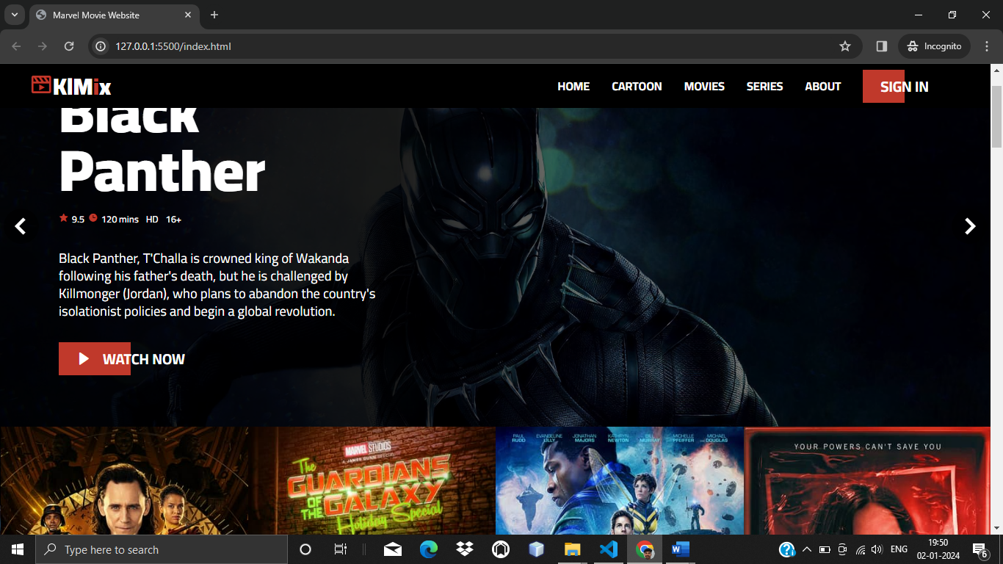

**LOGIN PAGE**

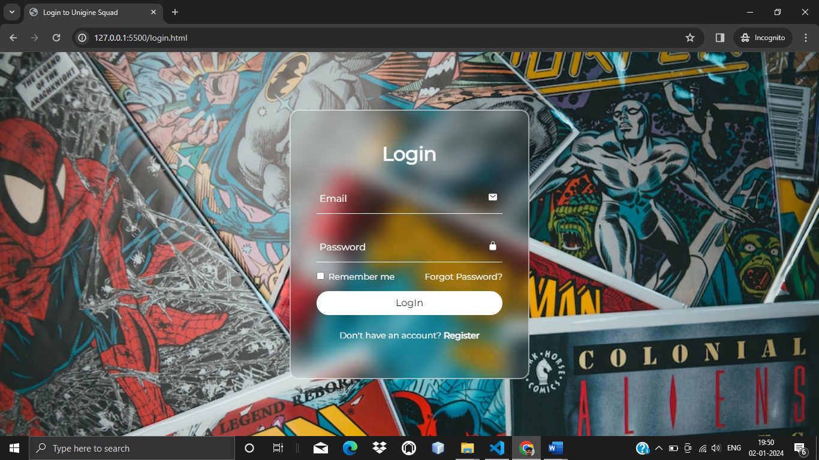

**Forget Page:**

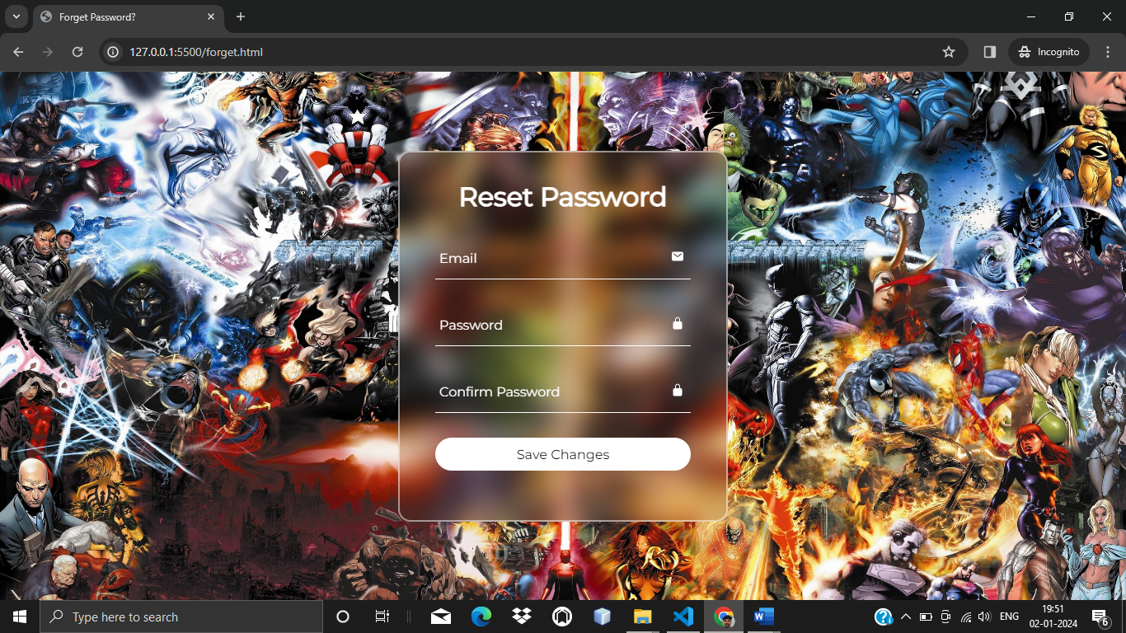

**Register Page:**

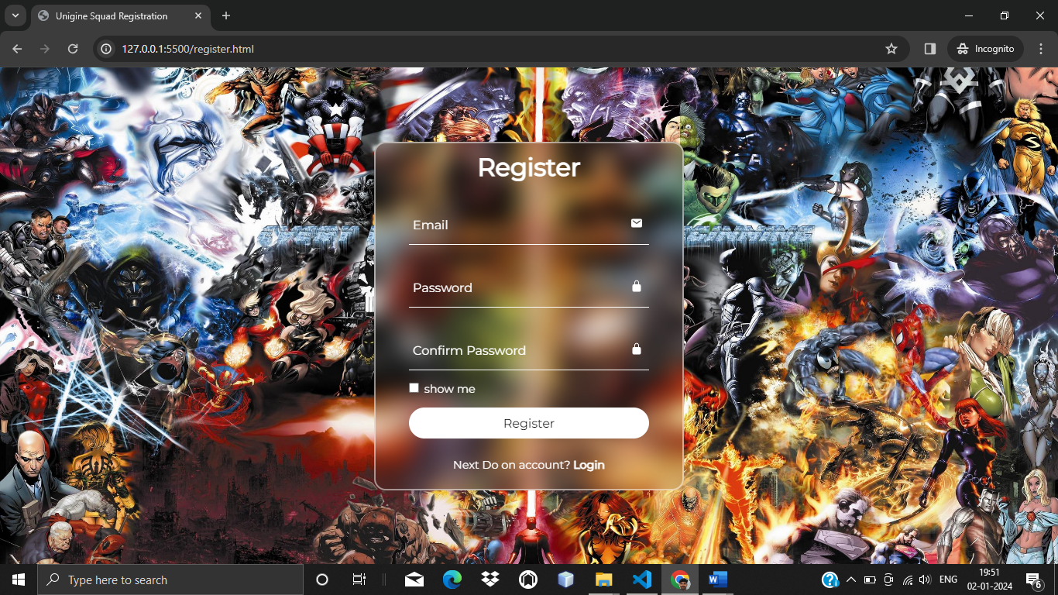

**CONCLUSION:**

The project was submitted and executed Successfully.